Rough Riders Drill Club
Annual Fund Raiser

MOUNTED POKER RIDE
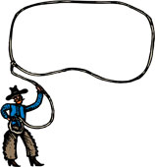

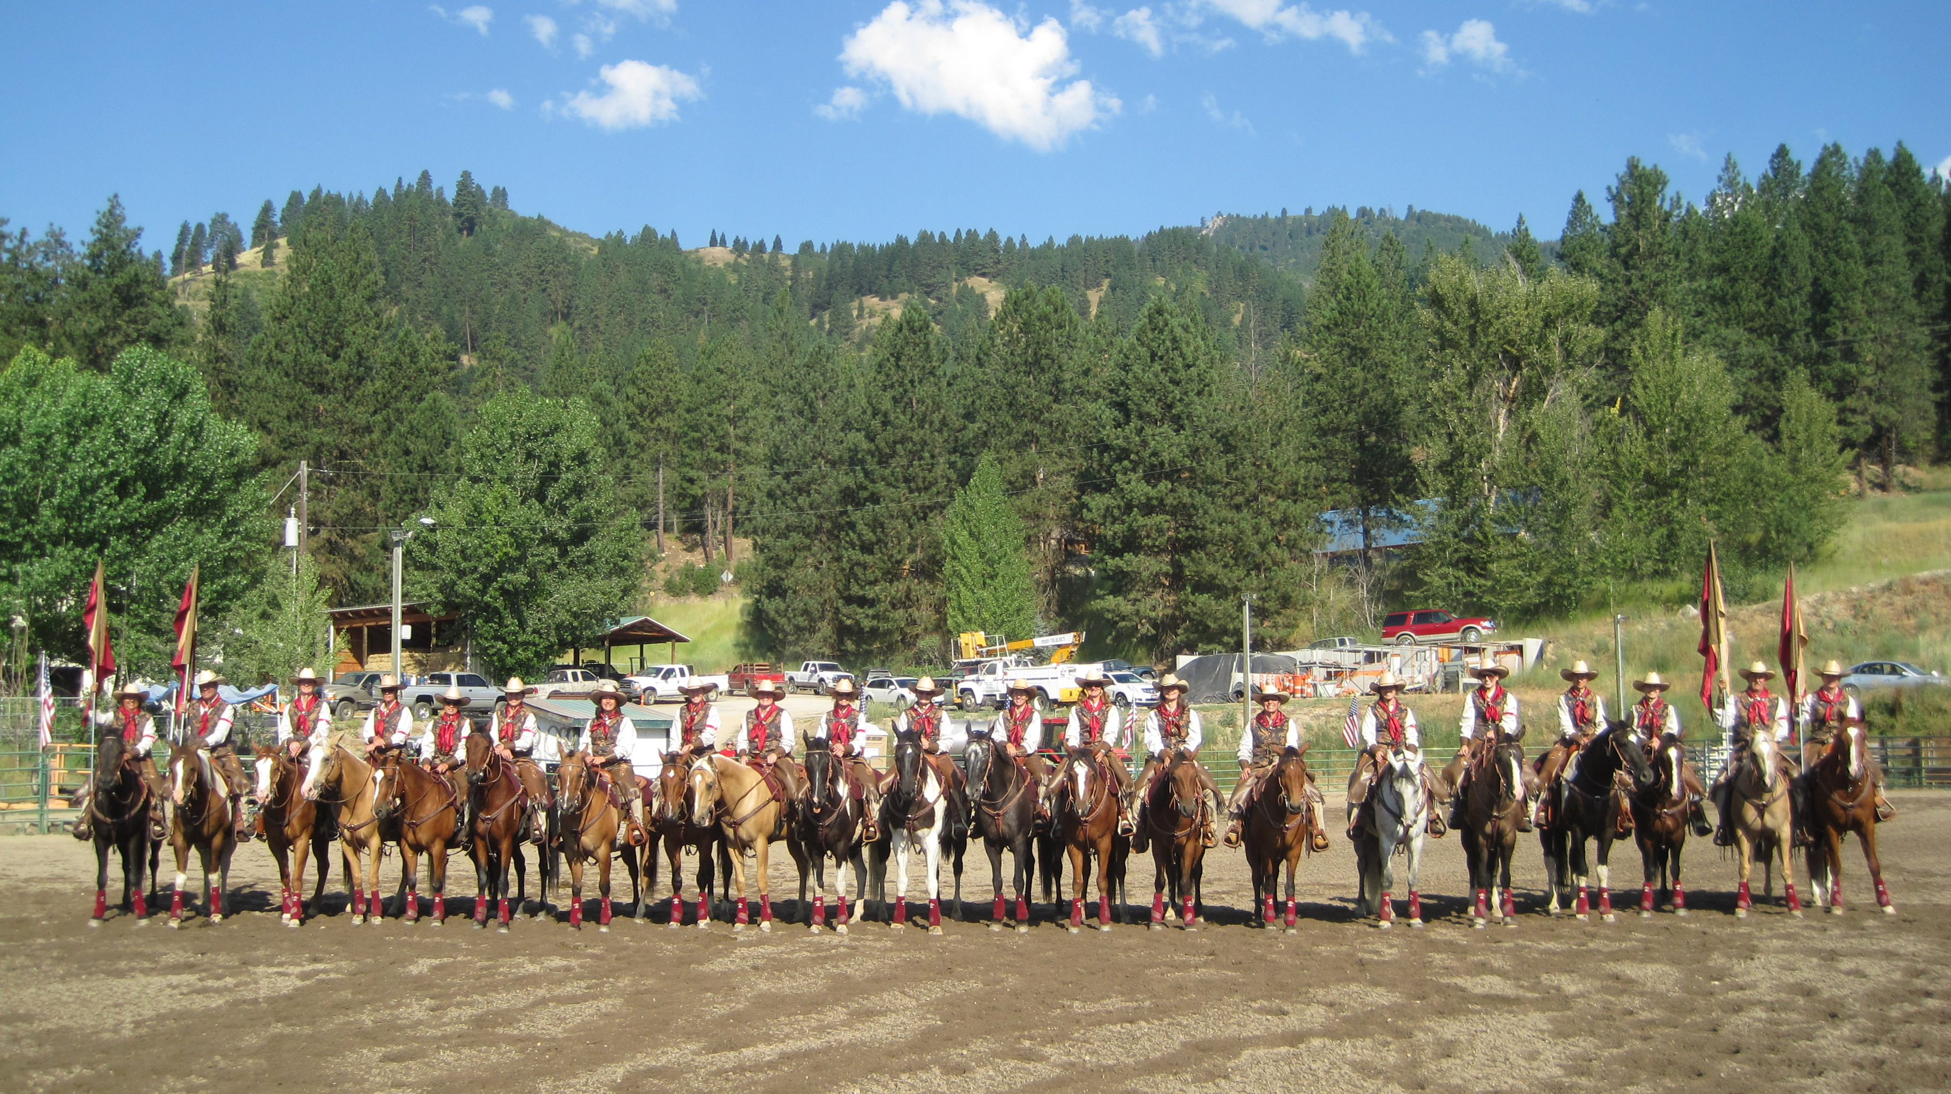
Saturday October 15th
2011 @ 10:00am

Saddle up your horses and join us for a Trail Ride at
Wilson Creek

Poker Ride will begin at 10:00 AM, October 15th, 2011. Come and meet trail riders like you!

Entry Fee $15.00 – this includes a BBQ of pulled pork sandwiches/sides and of course delicious pies donated by Marie Callender.

Improve your skills testing the obstacle courses at each station for a sweet treat.
2 -Winning Poker hands (one at 12:30 PM / one at 2:00 PM)

RAFFLE PRIZES throughout the day!

Come ride the trails, relax at camp and enjoy our friendly BBQ and learn about the
Rough Riders Drill Club.
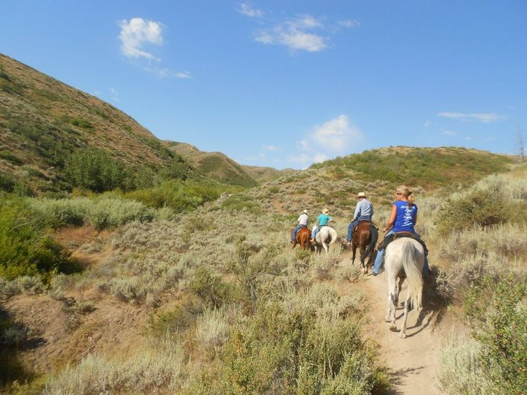
DIRECTIONS to Wilson Creek Road, Owyhee:
I-84 to Nampa (Franklin Blvd exit 36), Left on Franklin Blvd. Right onto 11th Ave. Left onto ID 45/ S E 3rd. Turn Right onto ID 45/12th Ave continue south out of Nampa on Hwy 45 (about 17 miles) Cross the river and at Junction of 45 and 78 Turn Right, 3.1 miles make a Left on Wilson Creek Road 3.1 miles.
***Questions Please Contact Christine Sword Ph 495-2955***

Fundraiser for the Nampa Rough Riders Drill Club, support goes to fund our expenses for the coming year 2012. http://www.roughridersdrill.org/ also look us up on Facebook.

